# **53. WAN ARCHITECTURES**

## **Introduction to WANs**

* **WAN** stands for **Wide Area Network**.
* A WAN is a network that extends over a large geographic area.
* WANs are used to connect geographically separate **LANs**.
* Although the **Internet** can be considered a WAN, the term "WAN" typically refers to an enterprise's **private connections** that link offices, data centers, and other sites.
* Over public/shared networks like the **Internet**, **VPNs (Virtual Private Networks)** can create private WAN connections.
* Many different **WAN technologies** exist. Availability depends on location.
* Technologies considered **"legacy" (old)** in one country may still be in use elsewhere.

## **WAN Over Dedicated Connection (Leased Line)**

### **Hub-and-Spoke Topology**

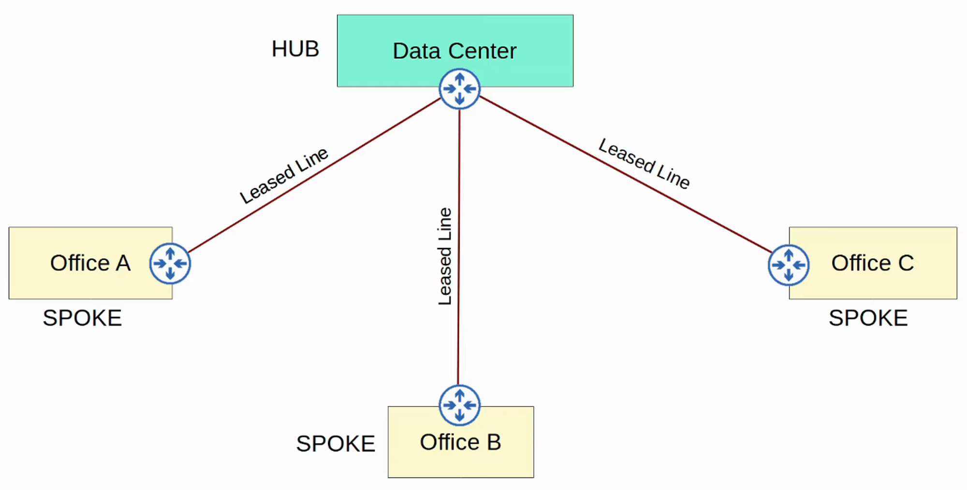

### **WAN Connection via Ethernet (Fiber)**

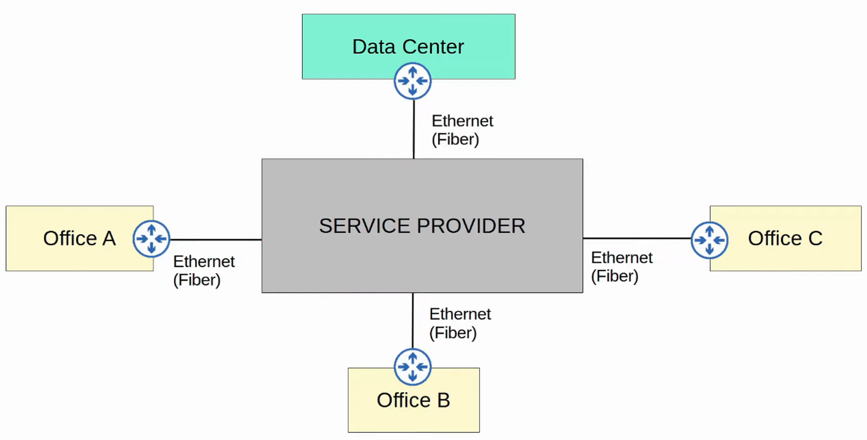

### **WAN Over Shared Infrastructure (Internet VPN)**

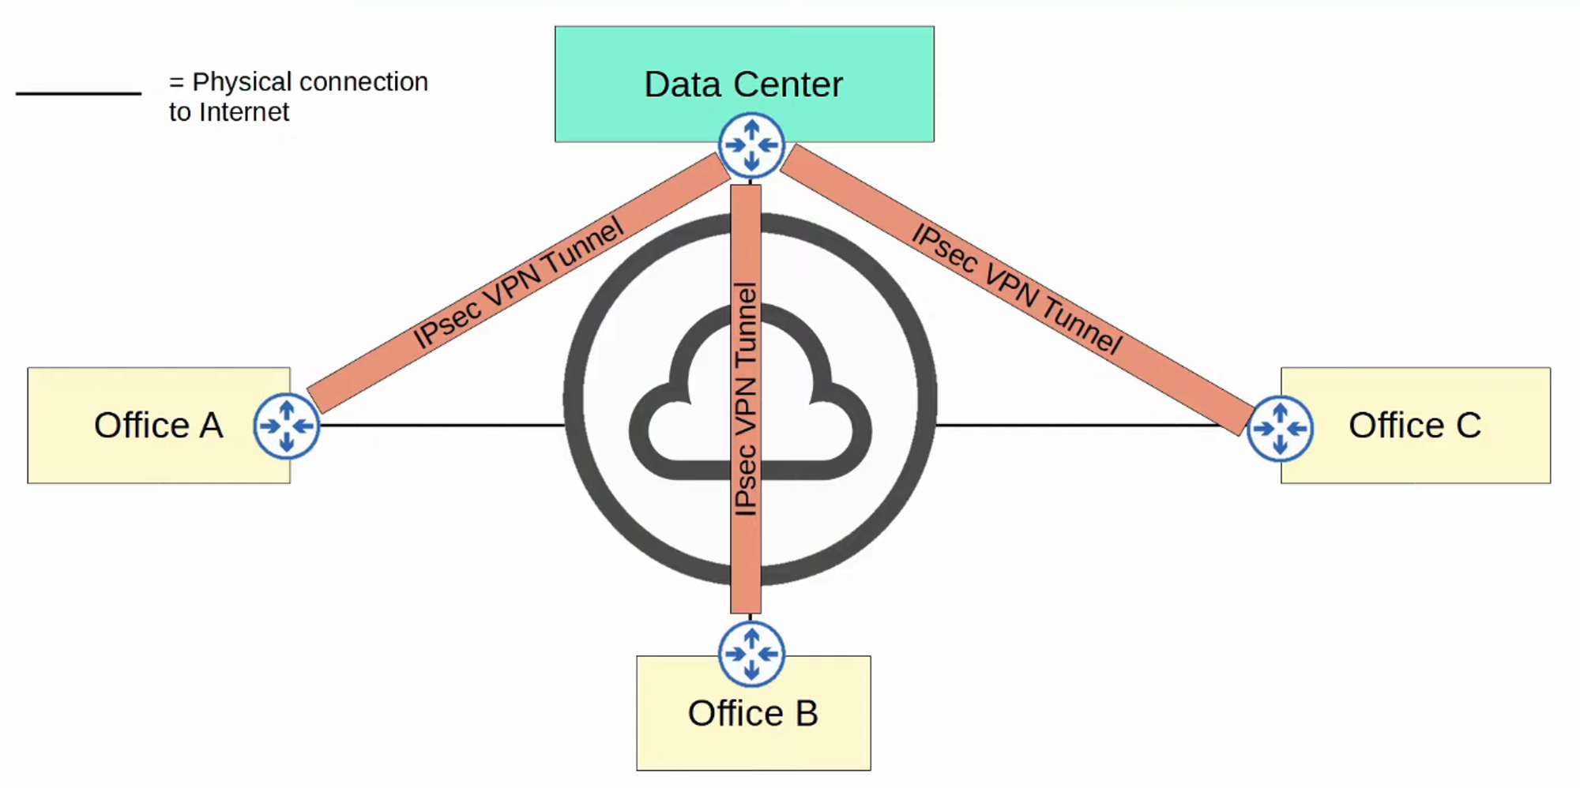

## **Leased Lines**

* A **Leased Line** is a dedicated physical link, typically connecting two sites.
* Uses **serial connections** (PPP or HDLC encapsulation).
* Various standards provide different speeds, available per region.
* **Ethernet WAN** is becoming more popular due to:
  + Lower **cost**
  + Faster **installation**
  + **Higher speeds**

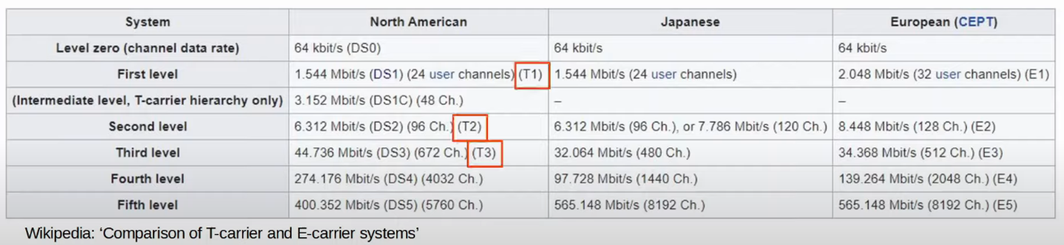

## **MPLS VPNs**

* **MPLS** stands for **Multi-Protocol Label Switching**.
* Similar to the **Internet**, MPLS networks are shared infrastructure, but **labels** allow for VPNs.
* **Key Terms:**
  + **CE Router** = Customer Edge Router
  + **PE Router** = Provider Edge Router
  + **P Router** = Provider Core Router

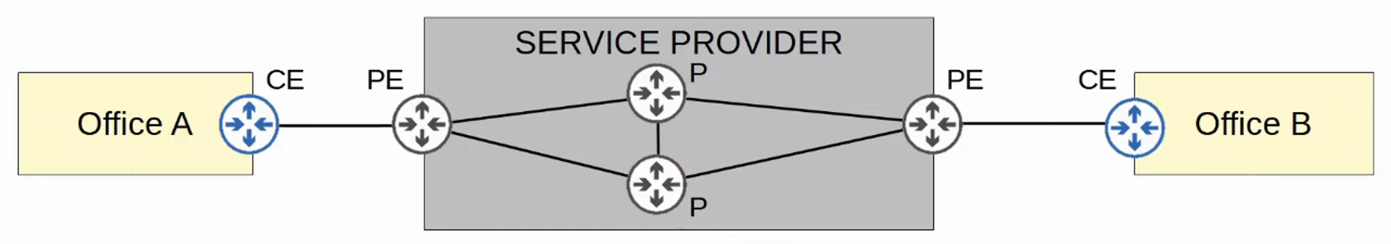

* **CE Routers** send frames to **PE Routers**, which **add labels** for forwarding.
* **Labels** (not IP addresses) determine traffic flow within the service provider network.
* **CE Routers do NOT use MPLS**; only **PE and P routers** do.
* Two types of **MPLS VPNs**:
  + **Layer 3 MPLS VPN**: CE and PE routers peer using **OSPF** to share routes.
  + **Layer 2 MPLS VPN**: CE routers are connected **as if on the same subnet**.

## **Internet Connectivity**

* Enterprises connect to the **Internet** using:
  + **Private WANs** (Leased Lines, MPLS VPNs)
  + **Consumer technologies** (CATV, DSL)
  + **Fiber Ethernet** (growing in popularity)

### **Digital Subscriber Line (DSL)**

* Uses **phone lines** for Internet.
* Requires a **DSL modem**.

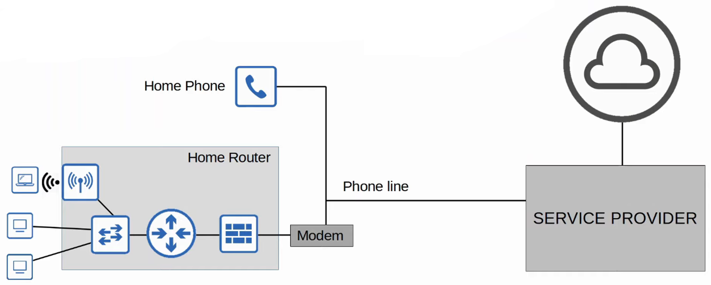

### **Cable Internet**

* Uses **CATV (Cable TV)** lines.
* Requires a **Cable Modem**.

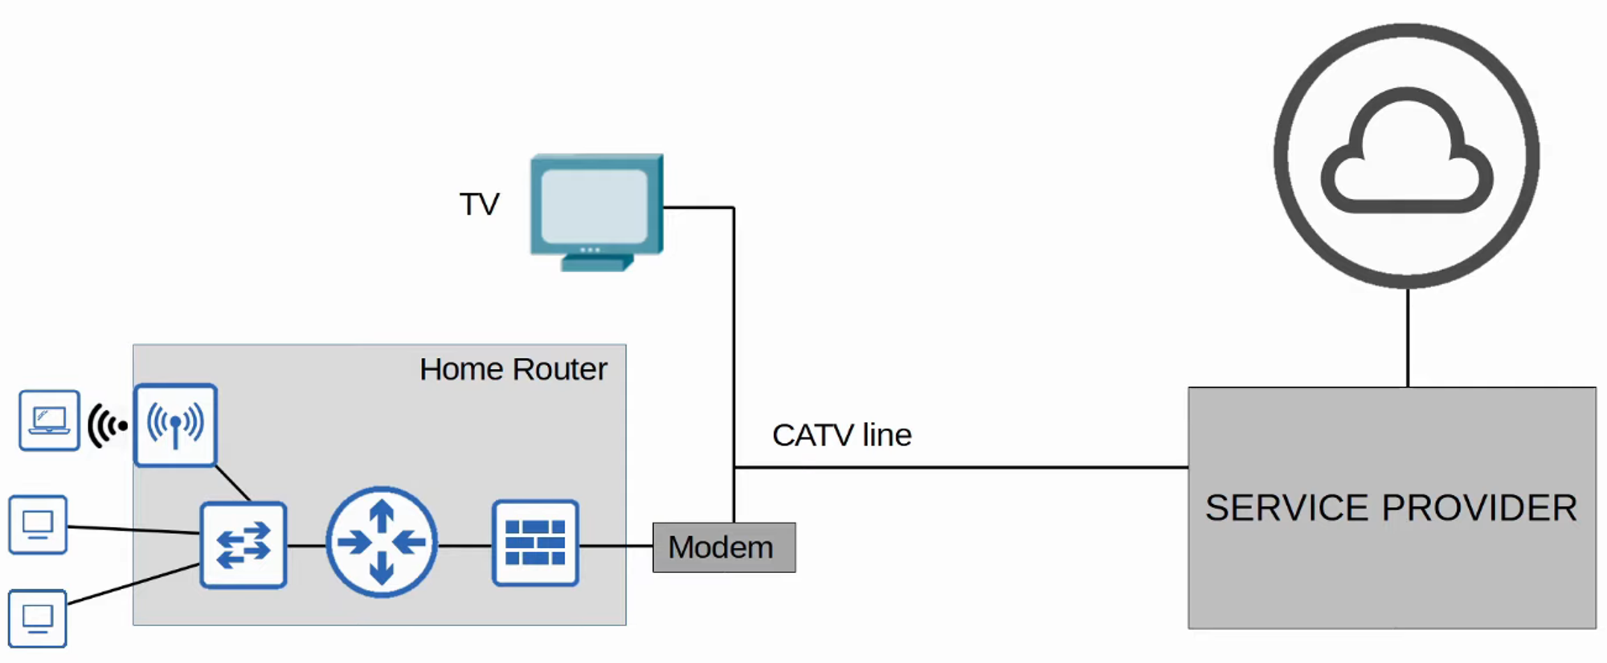

### **Redundant Internet Connections**

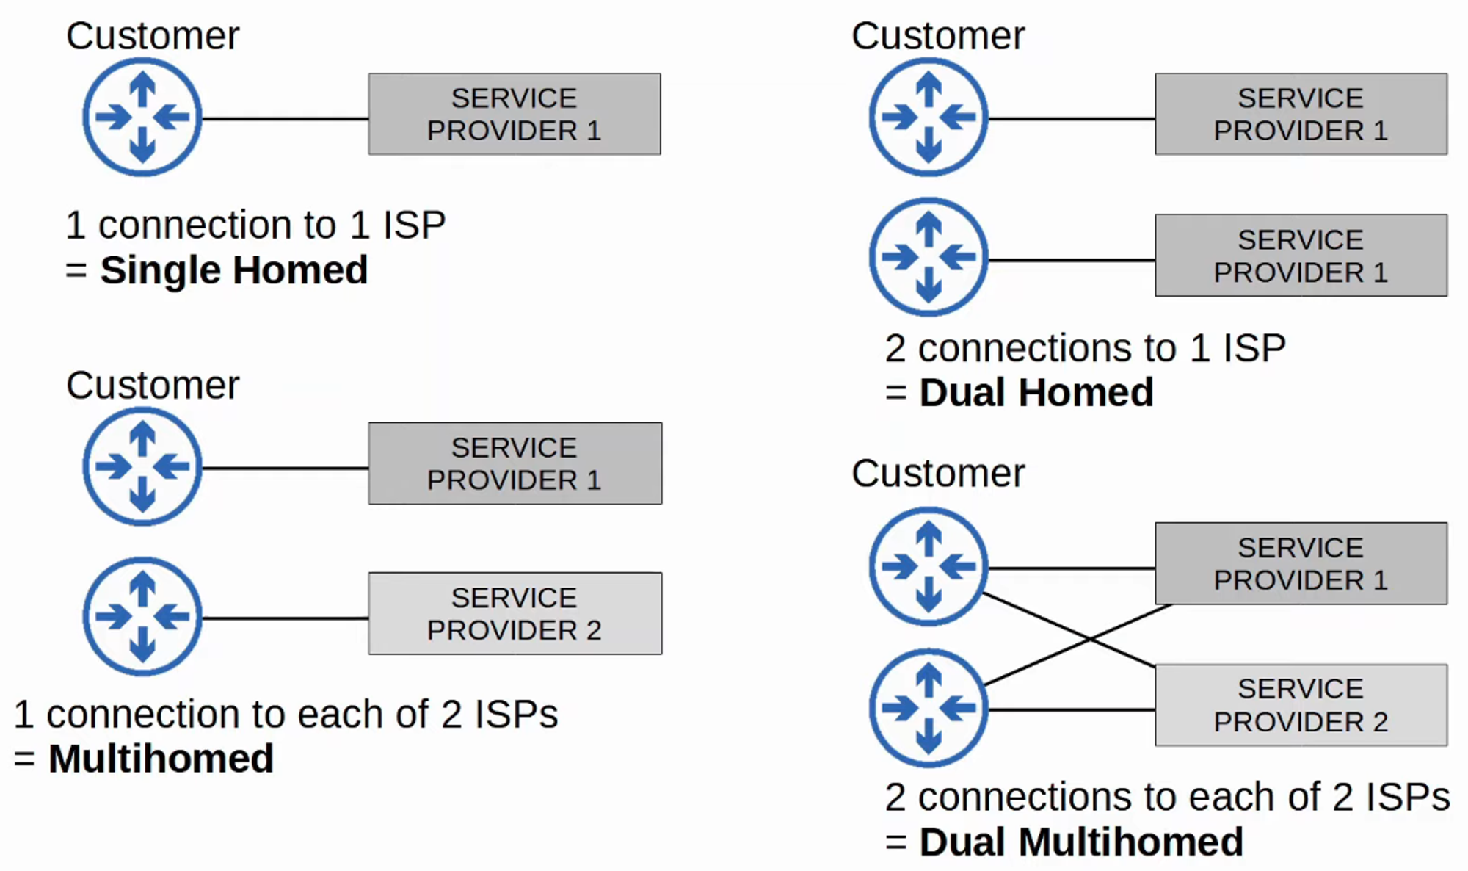

## **Internet VPNs**

* **Leased Lines** and **MPLS** offer security by physically separating traffic.
* **Internet-based WANs** lack built-in security.
* **VPNs (Virtual Private Networks)** provide secure Internet communications.
* Types of Internet VPNs:
  + **Site-to-Site VPNs** (IPSec)
  + **Remote-Access VPNs** (TLS)

### **Site-to-Site VPNs (IPSec)**

* A VPN **tunnel** connects two **devices/sites** over the Internet.
* **Process:**
  1. **Encrypt** original packet.
  2. **Encapsulate** with VPN & new IP headers.
  3. **Send** through the tunnel.
  4. **Decrypt** at the destination.

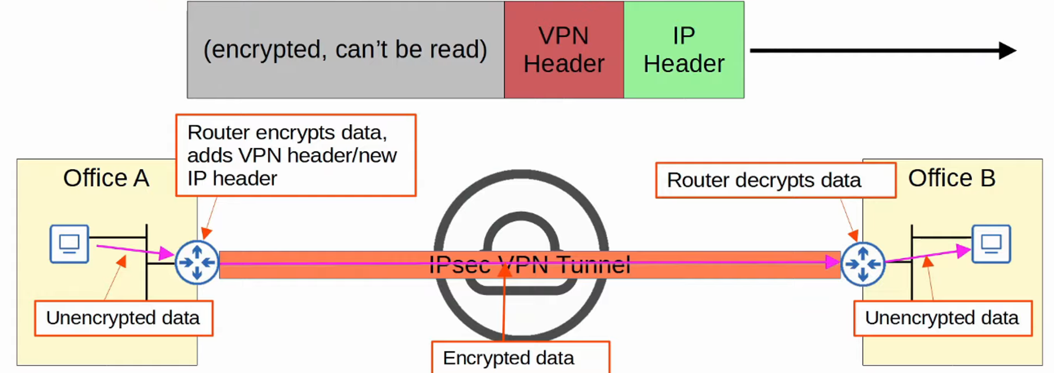

## **Limitations of Standard IPSec**

1. **No support for broadcast/multicast traffic** → Cannot run OSPF.
   * **Solution**: Use **GRE over IPSec**.
2. **Manual tunnel configuration is complex**.
   * **Solution**: Use **DMVPN**.

### **GRE over IPSec**

* **GRE (Generic Routing Encapsulation)**:
  + Supports **broadcast and multicast**.
  + **Not secure** by itself.
* **Solution**: GRE is **encrypted** within IPSec.

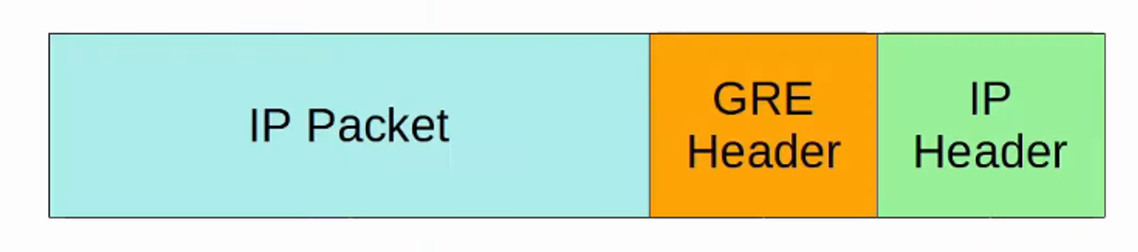

### **DMVPN (Dynamic Multipoint VPN)**

* **Cisco-developed solution** to dynamically create a **full mesh of IPSec tunnels**.
* Reduces manual tunnel configuration.